
Instabright
International Journal of Multidisciplinary Research
RESEARCH ARTICLE

OPEN ACCESS  ARTICLE INFO  Received:  June 11, 2024  Revised:  July 18, 2024  Published Online  August 15, 2024 | Evaluating the Impact of Facebook Use on Grade 12 Humanities and Social Science Students' Academic Performance at Nasugbu East Senior High School  Jerico N. Mendoza  Nikko C. Panotes  Nasugbu East Senior High School, Philippines.  *Corresponding Author Email: jerico.mendoza@deped.gov.ph
KEYWORDS  Facebook  Academic Performance  Humanities  Social Sciences | ABSTRACT  This study Evaluated the Impact of Facebook use on Grade 12 Humanities and Social Science Students' Academic Performance at Nasugbu East Senior High School, Academic Year 2023-2024. Descriptive research method was employed in the study that involved two hundred eighty-four (284) Grade 12 students. One hundred sixty-four (164) Grade 12 students were the respondents of the study selected through Raosoft sample size calculator. It is quite likely that respondents stated that Facebook is a useful tool for students to interact and communicate with one another rather than necessary for finding information that will help them with their academic studies. Additionally, they said that Facebook's contribution to their learning process is limited to educating students about specific topics that they can use to their education in order to improve their academic performance. In a similar vein, there is a notable disparity between how students view their use of Facebook and how much it influences their academic learning. Although they consider Facebook to be a communication tool, they conclude that its main contribution to students' learning is raising awareness of particular concerns. Lastly, an action plan is proposed in managing the extent of utilizing Facebook to the academic performance of students in Humanities and Social Sciences.  INTRODUCTION  In this generation, where technology is employed almost everywhere, it has impacted and integrated itself into our daily life. Online social media innovation brought about by this emergent scenario has transformed classic message methods into more contemporary ones like private messaging and broadcasting on feeds. Facebook facts (2013) actually state that individuals use the platform to share and express their thoughts and feelings, stay educated and entertained within their social circles, and stay in touch with friends and family.  The most talked-about issues among all students, both inside and outside of the classroom, are social networking sites, particularly Facebook. Launched in February 2004, Facebook is a social networking service owned and operated by Facebook, Inc. As of January 2023, Facebook had over 2.963 billion users, of which over half accessed the social media platform via a mobile device. Facebook has a significant impact on social interactions, so it's crucial to know what limits you have when using it and how it might help you as a student accomplish academically.  In our generation, Facebook use has skyrocketed; all learners who utilize this platform see changes in their life. Facebook also keeps generating conversation about user performance. Facebook users who spend a lot of time on social media are students in particular, and this has parents and educators worried about their academic performance. Furthermore, academic learning and performance have been the main focus of studies and research about the impact of information technology on schools. However, there may be a threat to the relationship between academic learning and information technology because Facebook is so widely used on college campuses.

Recent studies have demonstrated the effect of Facebook on pupils' academic performance. Although some research indicates that students' grades decline after joining Facebook, the students claimed that their use of the social media platform as a recreational activity had no effect on their academic performance.
Facebook use may have a favorable or unfavorable effect on their lives and academic performance. Students persisted in using Facebook in spite of the evidence demonstrating its negative effects on their academic performance. Facebook is so important to learners that they use it for more than just keeping in touch with people—they use it to get news and information from across the nation. The significant question of whether Facebook use influences students' academic performance and has a positive or negative impact on their social and academic lives is brought up by the extensive use of the social media platform by students. As a result, the study will look into how Facebook affects kids' academic performance.
Researchers at Nasugbu East Senior High School are trying to find out what the pupils think about the connection between Facebook use and academic success. For students, using Facebook may have a variety of advantages or disadvantages. Therefore, the researchers are interested in learning about the advantages and disadvantages of using this in terms of academic achievement.
The researchers want to assess how much Facebook use affects grade 12 humanities and social science students at Nasugbu East Senior High School's academic performance.

METHODOLOGY
This study used a descriptive method of research. Descriptive method of research is a type of research that is used to describe the characteristics of a population.
According to Gay et. al (2016) descriptive research method is significant as surveys abound in educational research and are utilized by many researchers as an investigative tool to collect data in order to address educational questions.
This study conducted at Nasugbu East Senior High School, located at Barangay Lumbangan Nasugbu Batangas. It was founded in the year 2016. The school is headed by school principal II and forty-seven (47) teachers. It has a total population of one thousand three hundred seventy-nine (1379) students.
The respondents of the study are the selected students of Grade 12 Humanities and Social Sciences in Nasugbu East Senior High School for SY 2022-2023. However, Administrators, Head teacher and grade 12 HUMSS teachers are expected to play a vital role in this study to make the results more valid and reliable.
The main instrument used in this study was survey questionnaire for the analysis of existing documents which supported by the validation of data.

RESULTS AND DISCUSSIONS
This chapter presents the data gathered, analysis and interpretation to answer the problem which this study aims to achieve.
Student’s Perception of Facebook Usage
Table 1 presents the student’s perception on Facebook usage which shows item number 2 that Facebook is a good platform for students to communicate and connect with others receives mean of 1.77 and a standard deviation of 1.48 with a verbal interpretation of very likely. It was immediately followed by the item number 3 that Facebook is a helpful tool for students on browsing videos that are educational and useful in learner’s academic journey that got a mean of 2.19 with a standard deviation of 1.83 with a verbal interpretation of likely. On the other hand, it is stated in item number 5 that Facebook is an app that students can use to search for necessary information that learners needed for their study received a mean of 2.37 with a standard deviation of 2.07 with a verbal interpretation of likely. Overall, the respondents’ response on the student’s perception of Facebook usage received a composite mean of 2.19 and a standard deviation of 1.87 with a verbal interpretation of likely.
With these results, it can be easily inferred that students mostly see Facebook as a helpful tool for communicating and making connections with others as it is widely used among other social media applications around the world.
Similarly, the study conducted by Eghdam E., et al., (2020) revealed that Facebook is the most popular social networking site in the world, with 1.65 billion monthly active users on average, 92% of whom access it via mobile devices. In general, users use Facebook to communicate with relatives, friends, and others who share similar interests. The group function is excellent for those who have a shared interest in sharing their ideas and communicating about the group’s topic or goal.
The extent of Facebook to the academic performance of learners
Table 2 presents the extent of Facebook to the academic performance of learners in item number 2 that Facebook provides awareness for learner about certain issues that they can use in their learning process with a mean 2.11 and standard deviation of 1.71 with a verbal interpretation of appropriate. It was immediately followed by item number 4 that states with the use of Facebook, students gain more creative ideas and helpful tips to be more productive in different learning areas that got a mean 2.18 and standard deviation of 1.84 with a verbal interpretation of appropriate. While on the other hand, it is said in item number 1 that Facebook allows students to perform well in school received mean of 2.39 and standard deviation of 2.04 with a verbal interpretation of appropriate. Overall, the extent of Facebook to the academic performances of learners are all appropriate based on the respondents with a composite mean of 2.24 and a standard deviation of 1.88.

Table 1. Student’s Perception of Facebook Usage.
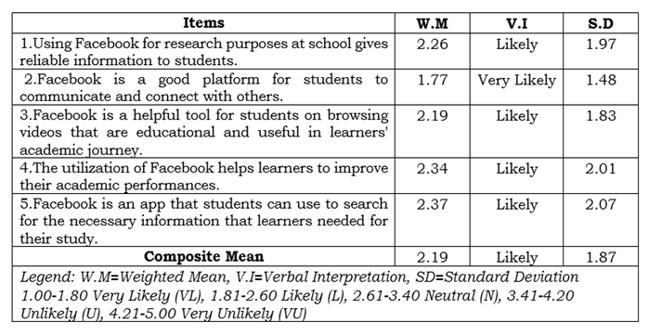

With these result, Facebook provides awareness about certain issue for learner to use in their learning process and also with the use of Facebook, students gain more creative ideas and helpful tips to be more productive in different learning areas, and one another hand Facebook allows students to perform well in school.
Similarly, to the study conducted by Karim et al. (2019) stated that the Advancement of technology has changed social and academic lives. It provides a facility for people to communicate anywhere at any time diversely such as through electronic mail, instant messages, and social networks. The use of social networks is common among students and also builds a distraction for students. The results show Facebook with academic performance has a negative relationship and a medium correlation with Multitasking has positive that Facebook is not the only factor to enhance multitasking but also enhances other activities of Facebook that can affect students which means there is a relationship between multitasking and using Facebook where Health factor has low correlation and negative relationship might get the cause to indirectly affect the student's academic performance.

Table 2. The extent of Facebook to the academic performance of learners.
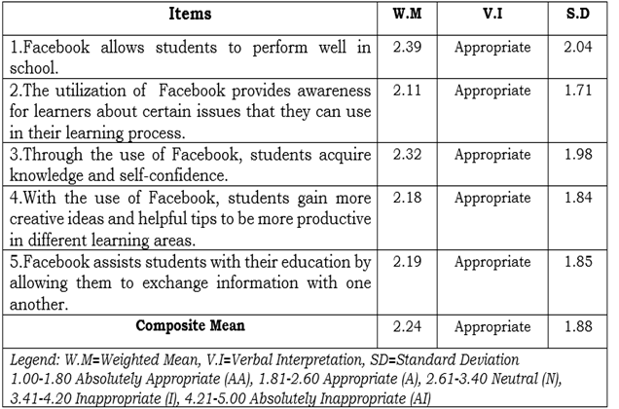
Academic benefits of learners in using Facebook
Table 3 presents the academic benefits of learners in using Facebook, states in item number 5 that using Facebook for educational purposes encourages students to meet and talk online received a mean of 1.96 and standard deviation of 1.61 with verbal interpretation of agree. It was followed by item number 4 that through the use of Facebook, learners can enhance their communication skills with also got a mean of 1.96 and standard deviation of 1.67 with a verbal interpretation of agree. Lastly, item number 2 reveals that Facebook is said that serves as a platform for students to gather news and information relevant to their studies that got the composite mean 2.23 of standard deviation of 1.88 with a verbal interpretation of agree. Overall, the respondents agree on the academic benefits of learners in using Facebook with a composite mean of 2.09 and a standard deviation of 1.75.
With these results, Facebook can help to improve the learning abilities of a learners and also Facebook serves as a platform to gather various information that is relevant to their studies, and through the use of Facebook it helps the learners to enhance their communication skills.
This is related to the study of Tus et al., (2021) said that students use social media to do academic work, get information about current events, read recent news, and many more. Furthermore, students also use it for their enjoyment and pleasure, such as watching movies, communicating with their friends and relatives, and looking at funny media. It is also a way to unwind themselves from academic stress. Thus, this study concluded that social media usage has a positive effect on students' academic performance. This proves that social media has a significant impact on the environment, especially on students.

Table 3. Academic benefits of learners in using Facebook.
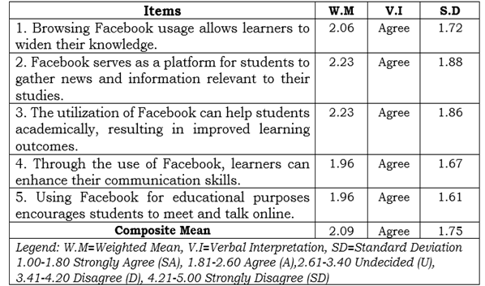

Significant difference between the perception of students in utilizing Facebook and the extent of Facebook to the academic performance of students
There is a significant difference between with these two variables, the perception of students in utilizing Facebook said that, Facebook is a good platform for students to communicate and connect with others and followed by the perception that Facebook is a helpful tool for students on browsing videos that are educational and useful in learner’s academic journey. While on the other hand, the extent of Facebook to the academic performance of students showed that Facebook provides awareness for learner about certain issues that they can use in their learning process and immediately followed by with the use of Facebook, students gain more creative ideas and helpful tips to be more productive in different learning areas.
With these results, it is clearly that there is a significant difference between the perception of students in utilizing Facebook and the extent of Facebook to the academic performance of students. They see Facebook as a platform of communication and for browsing video but the extent of Facebook to their learning process is it gives awareness about certain topics and be more creative in the field of learning.
Similar to the study of Lim (2021) that stated that the ubiquity of Facebook as a social media leads to a promising idea that it can be used as an alternative learning platform for students. It is a low stake, high-impact communication platform to engage with the students and parents, and the school community quickly. While many perceived the use of Facebook as beneficial and convenient, there is still a fraction who found the use of Facebook troublesome and distracting. This is an obvious fact because Facebook is a social media and is primarily intended for information sharing and buzzing. Thus, the use of other social media platforms can be explored to be used as an alternative learning platform. The ubiquity of the application and user-friendliness that includes features for student interaction and data consumption must be considered in the overall selection of the application.

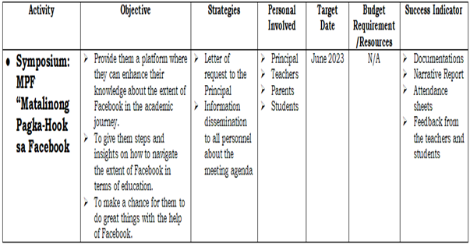
Table 4. Proposed action plan to manage the extent of utilizing Facebook to the academic performance of students in Humanities and Social Sciences.

CONCLUSIONS
Based on the findings of the study, the following conclusion are drawn:
- The majority of the respondents very likely to said that they see Facebook as a good platform for students to communicate and connect with others and not necessarily for searching of information that the students can use in their academic learning.
- Based on the answers to the survey questionnaires, the majority of the respondents indicated that Facebook extent to their learning process is to provides awareness for learner about certain issues that they can use in their learning process in regards of how Facebook allows them to perform well in school.
- The results show that utilizing Facebook for educational purposes encourages students to meet and talk online rather than to use it as to gather necessary and relevant information online.
- There is a significant difference between the perceptions of students to the utilization of Facebook and the extent of it to their academic learning process. Majority of the respondents believes that Facebook is a communication tool but they conclude that Facebook extent to their learning process is to provide awareness for learner about certain issues.
- An action plan is proposed in managing the extent of utilizing Facebook to the academic performance of students in Humanities and Social Sciences.

RECOMMENDATIONS
Based on the conclusions that have been written in the previous section, and based on the needs of the respondents who participated in this study, it is possible in formulate a number of recommendations.
- Students should be aware the use of Facebook because it can may affect academic performance and cause a loss of interest in activities in school.
- Educators should educate students on responsible social media usage and set clear guidelines for its use in the classroom.
- Encourage students on the creation of educational groups and communities on Facebook, fostering collaboration, knowledge sharing, and peer support for academic pursuits.
- Parents and Educators should actively engage in open discussions with students about the responsible use of Facebook, promoting awareness of its potential impact on academic performance.
- Learners, Educators and Parents should learn how to navigate the extent of utilizing Facebook in terms of education. They must do great things with Facebook as an advantage.

KEYWORDS:
The following terms are defined conceptually and operationally in the study.
Academic Achievement. It refers to the extent to which a student, teacher, or institution has attained their short or long-term educational goals. In this study, it is defined as the achievement or goals of the students wherein Facebook is used as one of their major tools in learning, to see if there is some changes or none in their academic performance.
Academic Performance. It refers to the measurement of student achievement across various academic subjects. In this study, the performance of
the learners is being assessed even if they are utilizing Facebook as a new way of acquiring knowledge, entertainment, and relaxation. Thus, the use of Facebook has a negative or positive impact on student academic achievement and performance.
Distraction. Refers to an impediment. It is something that takes your attention away from the area on which you want to concentrate. In this study, it was defined as something that may cause a student to lose focus while studying, such as uncontrollable exposure to various social media platforms such as Facebook.
Educational Journey. It refers to the composed stages whose progression is dictated by the student's performance and steps up to the next level. In this study, it is simply the journey of students in their educational progress with the help of utilizing Facebook as one of their platforms for learning.
Extent. It is defined as the range, distance, or space that is covered or affected by something or included in something. In this study, it refers to how utilizing Facebook brought an impact on Grade 12 HUMSS learners' academic performances.
Facebook. It is defined as a social networking site that makes it easy for you to connect and share with family and friends online. In this study, it refers to the platform that Grade 12 HUMSS uses to help them with their academic-related performances.
Innovation. It refers to the making of changes in something established, especially by introducing new methods, and ideas to the way something is done or made. In this study, the Facebook app is used to make different methods of teaching or learning processes for them to be more active in performing at the school.
Modern Teaching. It refers to the teaching method which focuses more on teaching the students for improving their intellect behavior by using various new and innovative ideas rather than making them recite the syllabus to clear the examination with the same old style. In this study, it pertains to the method of teaching wherein the use of the Facebook app is considered as a platform of learning to make teaching more effective to students.
Platform. It refers to a service, website, or means for delivering media to an audience. Its functions are to provide, but it also occasionally allows for feedback, discussion, or sharing. In this study, it is used to define Facebook as one of the platforms that students use for educational purposes.
Social Media. It refers to the platform wherein individuals can create, edit and share the course contents in textual, video, or audio forms. These technological innovations give birth to a new kind of learning culture, learning based on the principles of collective exploration and interaction. In this study, it is defined as a tool, such as Facebook, that students can use to generate reflective thinking, construct knowledge, and consequently enhance learning, to have a new media of studying.
Social Networking Sites. It refers to an online platform that users use to create social networks or social interactions with others that have similar personal or career content, interests, hobbies, backgrounds, or real-life connections. In this study, it is used to emphasize how this kind of platform is used by students for academic purposes and how it gives highlight on Facebook as one of the examples that students commonly utilize.
Students. It refers to a person who is formally engaged in learning, specifically one who is enrolled in a school or institution. This study pertains to the Grade 12 HUMSS individuals who are involved in using Facebook and uses this platform to assist them in improving their academic performance.
Technology. It refers to the application of knowledge for achieving practical goals in a reproducible way. The word technology can also mean the products resulting from such efforts, including both tangible tools such as utensils or machines, and intangible ones such as software. In this study, it pertains to the tool that learners from this generation use to have a new method of learning inside or outside the school, such as advanced technology equipment to access in the Facebook app.
Traditional Teaching. It refers to the structured education program that focuses on face-to-face teacher-centered instruction, including teacher-led discussion and teacher knowledge imparted to students. In this study, it focused on the teacher as the only source of information in the classroom. It embraces the idea of a teacher-centered method involving face-to-face interaction, mainly from the teacher to the student.
Utilizing. It refers to how to put something to good use, especially to make profitable or effective use of an idea, thing, object, information, etc. In this study, it pertains to the use of Facebook as a modern way of acquiring knowledge and information around the world. It also includes how the use of Facebook affects the academic performances of Grade 12 HUMSS learners.

REFERENCES
AL-DHELEAI, Y. M., & TASIR, Z. (2017). Using Facebook for the Purpose of Students’ Interaction and its Correlation with Students’ Academic Performance. TOJET: The Turkish Online Journal of Educational Technology, 16(4), 170-178.
https://scholar.google.com/scholar?cluster=7910144488487260767&hl=en&as_sdt=2005&sciodt=0,5#d=gs_qabs&t=1677921417118&u=%23p%3DXxJMpoB6xm0J
Arlantico, A. A., Ferriol, L. G., Mantal, R. M., Monteroyo, M. R., Nicolas, I. M., & Tandoc, A. (2019). The Effects of Facebook on the Academic Performance of Grade 11 Students of Bestlink College of the Philippines. Ascendens Asia Singapore–Bestlink College of the Philippines Journal of Multidisciplinary Research, 1(1).
https://ojs.aaresearchindex.com/index.php/aasgbcpjmra/article/view/1223
Boholano, H. B. ., & Cajes, R. (2021). The Utilization of Facebook During Covid-19 Pandemic by First-Year College Students. International Journal of Social Learning (IJSL), 1(2), 163–173.
https://www.researchgate.net/publication/351014833_The_Utilization_of_Facebook_During_Covid-19_Pandemic_by_First-Year_College_Students
Carreon, A. V., Valenzuela, M. M., Tayag, J. R., & Dizon, C. S. (2019). Students who spend more time on Facebook tend to have higher grades: Findings from a Philippine university. International Journal of Research Studies in Education, 8(4), 27-37
https://scholar.google.com/scholar?hl=en&as_sdt=0%2C5&q=local+study+about+the+extent+utilizing+of+Facebook+on+the+academic+performance+in+grade+12&btnG=#d=gs_qabs&t=1677787288838&u=%23p%3DBstjEF43OiAJ
Eghdam, A., Hamidi, U., Bartfai, A., &amp; Koch, S. (2018, January 29). Facebook as communication support for persons with potential mild acquired COGNITIVE IMPAIRMENT: a content and social network study.
https://journals.plos.org/plosone/article?id=10.1371%2Fjournal.pone.0191878&amp;fbclid=IwAR2J40IknCdrsJXewYfJFt8RvbP8YjztAECaWCNyJHiDXCjf--1LXfBRWkE
Eloquina, G. (2018, May 30). Effects of facebook to the academic performance of Grade 12 in Southville 8-C San Isidro Rodriguez Rizal AY 2017-2018. Academia.edu.
https://www.academia.edu/36751407/EFFECTS_OF_FACEBOOK_TO_THE_ACADEMIC_PERFORMANCE_OF_GRADE_12_IN_SOUTHVILLE_8_C_SAN_ISIDRO_RODRIGUEZ_RIZAL_AY_2017_2018?fbclid=IwAR1Pr58GxLaTw3GTNtJ9PSfTZhZAhHzoCx02qmBgQiR3eSzUTLsKwRvJq4c
Karim, S., He, H., Mallah, G. A., Laghari, A. A., Madiha, H., & Larik, R. S. A. (2019). The impact of using Facebook on the academic performance of university students. In Artificial Intelligence and Security: 5th International Conference, ICAIS 2019, New York, NY, USA, July 26–28, 2019, Proceedings, Part III 5 (pp. 405-418). Springer International Publishing.
https://link.springer.com/chapter/10.1007/978-3-030-24271-8_37
Moghavvemi, S., Sulaiman, A., Aziz, A. A., & Wai, P. S. (2017, July). The impact of Facebook usage on academic performance. In 2017 International Conference on Research and Innovation in Information Systems (ICRIIS) (pp. 1-5). IEEE.
https://www.researchgate.net/publication/319056122_The_impact_of_Facebook_usage_on_academic_performance
Mufti, R., Saleem, M., & Basit, A. (2021). Usage of Facebook an Inspiration or a Distraction for Students on their Academic Performance. Sustainable Business and Society in Emerging Economies, 3(4), 521-529.
https://www.researchgate.net/publication/363151240_Usage_of_Facebook_an_Inspiration_or_a_Distraction_for_Students_on_their_Academic_Performance
Nadeem, S., Dhool, M. A., Butt, R. M., Rasheed, A., & Bashir, A. (2020). A Systematic review on the impact of Facebook usage on academic performance. Reviews of Management Sciences, 2(2), 17-39.
https://scholar.google.com/scholar?hl=en&as_sdt=0%2C5&q=foreign+study+about+the+extent+of+Facebook+to+the+Academic+Performance+of+the+students&btnG=#d=gs_qabs&t=1677834263627&u=%23p%3DHb5LRAzvaCUJ
Nwoburuoke, I. F., & Eremie, M. (2021). Influence Of Social Media On Academic Performance Of Senior Secondary School Students In Rivers State: Implications For Counseling. International Journal of Innovative Information Systems & Technology Research, 9(2), 48-61.
http://seahipaj.org/journals-ci/june-2021/IJIISTR/full/IJIISTR-J-7-2021.pdf
RA LIM (2021) The Use of Facebook as an Alternative Learning Platform: Perspectives from Transactional Distance Theory. Education Review, 10 (1), 63-82.
https://www.researchgate.net/publication/362124649_The_Use_of_Facebook_as_an_Alternative_Learning_Platform_Perspectives_from_Transactional_Distance_Theory
Rivera11, J. U., Andres, P. M. M., & Bron, G. B. THE HELPING FACEBOOK?: A STUDY ON THE PREVALENCE OF FACEBOOK AMONG GRADE 12 STUDENTS WITH HONORS.
http://www.urs.edu.ph/wp-content/uploads/publications/the-ursp-research-journal/current-issue/16-Rivera.pdf
Sulami, K. (2021, March 22). Flow theory in human-computer interaction design. Medium.
https://bootcamp.uxdesign.cc/flow-theory-in-human-computer-interaction-design-f7319c54e4c4
Triberti, S. et al (2021). Flowing technologies: The role of flow and related constructs in human, https://www.researchgate.net/publication/348641748_Flowing_Technologies_The_Role_of_Flow_and_Related_Constructs_in_Human-Computer_Interaction
Tus, J., Conquilla, J.,Espiritu, et al.,(2021). The Social Media Usage and Its Impact on the Filipino Learners' Academic Performance Amidst the Online Education. Research Journal. DOI:10.6084/m9.figshare.16997119.v2. https://www.researchgate.net/publication/356161965

